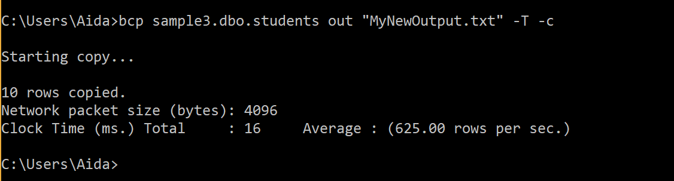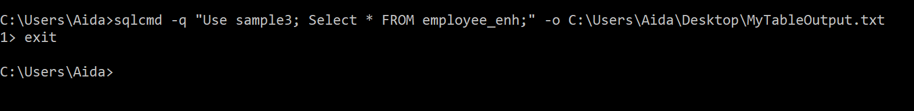

MyNewOuput.txt results

20001 James Perez Physics

20002 Nick Ribeira Mathematics

20003 John Smithy Economics

20004 Hernando Gonzalez MechEnigeering

20005 Glenn Smith Biology

20006 Jesse Cruz MgmtInfoSystems

20007 Ron Hubert Undeclared

20008 Maria Moro Undeclared

20009 Celia Beltran English

20010 Adlin Cruz Psychology

MyTableOutput.txt is below

Changed database context to 'sample3'.

emp_no emp_fname emp_lname domicile

----------- -------------------- -------------------- -------------------------

25348 Matthew Smith San Antonio

10102 Ann Jones Houston

9031 Elke Hansel Portland

2581 Elsa Bertoni Tacoma

28559 Sybill Moser Houston

32390 Andy Young Miami

43002 Glenn Spencer Miami

(7 rows affected)